**INTRODUCTION**

Caring for houseplants can be challenging, especially when it comes to remembering to water them regularly. Fortunately, soil moisture sensors come to the rescue, helping us keep track of our plant's hydration needs and ultimately extending their lifespan.

However, many affordable soil moisture sensors employ a resistive style, featuring two prongs that measure water content in the soil based on conductivity. While effective initially, these sensors tend to rust over time, even if gold-plated. The rusting process interferes with accurate readings, requiring constant code adjustments. Moreover, they may not perform well in loose soil.

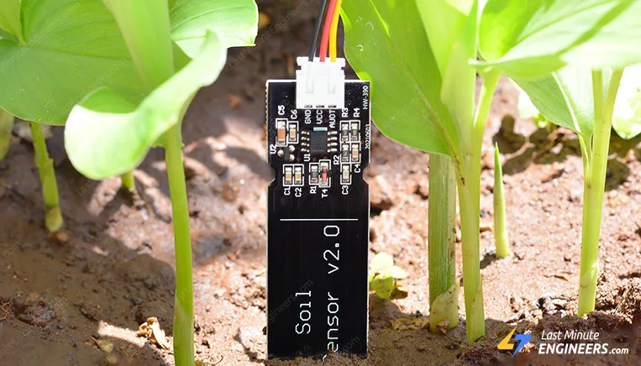

Enter capacitive soil moisture sensors, a superior alternative. These sensors operate on capacitive measurement, offering distinct advantages over their resistive counterparts. With just one probe and no exposed metal prone to rusting, capacitive sensors provide more reliable readings. Importantly, they avoid introducing electricity into the soil, ensuring the well-being of your plants. This innovation presents a more efficient and plant-friendly solution for monitoring soil moisture levels.

**Specifications: -**

* Operating Voltage: 3.3v – 5.5v DC
* Output Voltage: 0 – 3v DC
* Operating Current: 5mA
* Interface: PH2.0 – 3P
* Modes: AP, STA, AP+STA
* Output Signal: Analog Signal
* Supporting Interface: 3-Pin Gravity sensor

**Capacitive Soil moisture Sensor pinout**

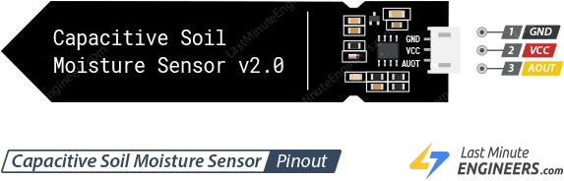

**VCC -** is the power supply pin. It is recommended that the sensor be powered from 3.3V to 5V. Please keep in mind that the analog output will vary depending on the voltage supplied to the sensor.

**GND -** is the ground pin.

**AOUT -** pin gives an analog voltage output that is proportional to the amount of moisture in the soil. The output can be read using an analog input on your microcontroller. As the moisture level increases, the output voltage decreases and vice versa.

**Hardware Overview**

This is an **analog capacitive soil moisture sensor** which measures soil moisture levels by **capacitive sensing**, i.e. capacitance is varied based on water content present in the soil. The capacitance is converted into voltage level basically from 1.2V to 3.0V maximum. The advantage of Capacitive Soil Moisture Sensor is that they are made of a **corrosion-resistant material** giving it a long service life.

**Capacitive soil moisture sensors utilize a 555 timer IC to measure the charging rate of a virtual capacitor formed by two PCB traces. The proximity of these traces allows their capacitance, and consequently their charging rate, to change in response to the surrounding water content. Unlike traditional capacitors, these sensors feature PCB traces as the capacitor's components.**

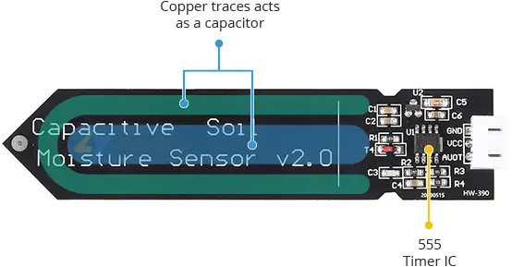

Equipped with an on-board 3.3V voltage regulator, these sensors are compatible with both 3.3V and 5V microcontrollers, drawing less than 5mA of current.

It's important to note that these sensors provide a qualitative measurement of soil moisture. As the soil becomes wetter, the output value decreases, and as it dries, the output value increases. When powered at 5V, the output ranges from approximately 1.5V for wet soil to 3V for dry soil.



However, variations in probe insertion depth and soil compaction impact the final output value, emphasizing the qualitative nature of the soil moisture measurement. Despite this limitation, these sensors offer a practical solution for gauging soil moisture levels in a variety of applications.

**Schematic Diagram**

**Schematic for Capacitive Soil Moisture Sensor** is given below:

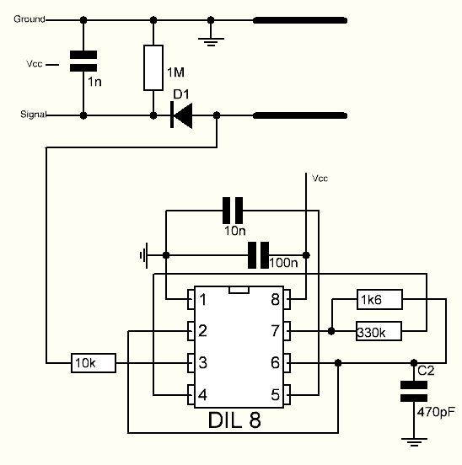

The capacitive soil moisture sensor employs a fixed-frequency oscillator constructed with a 555 Timer IC. The oscillator generates a square wave, which is then applied to the sensor as if it were a capacitor. When a square wave is applied to a capacitor, it introduces a certain reactance or, for simplification, a resistance that forms a voltage divider with a pure ohmic resistor (in this case, the 10k resistor on pin 3). The capacitance of the sensor is directly related to soil moisture content. As the soil moisture increases, the sensor's capacitance also increases, resulting in reduced reactance to the square wave.

This decreased reactance lowers the voltage on the signal line, and the voltage on the Analog signal pin can be measured by an analog pin on the Arduino. The measured voltage serves as an indicator of soil humidity, with higher humidity leading to a lower voltage reading. By monitoring this voltage, the Arduino can provide a quantitative representation of the soil moisture level. This method allows for an effective and responsive measurement of soil moisture using capacitive sensing principles.

**How Does a Capacitive Soil Moisture Sensor Work?**

Understanding the behavior of the capacitor in an RC circuit

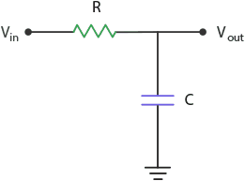

In a basic RC (resistor-capacitor) circuit, when a positive voltage is applied to the input, the capacitor (C) initiates the charging process through the resistor (R). As this occurs, the voltage across the capacitor undergoes a change. As time progresses, the voltage across the capacitor gradually increases until it reaches the same level as the input voltage. The process of charging a capacitor in this configuration follows an exponential curve. The graph visually represents the relationship between voltage and time during the charging phase of the capacitor in the RC circuit.

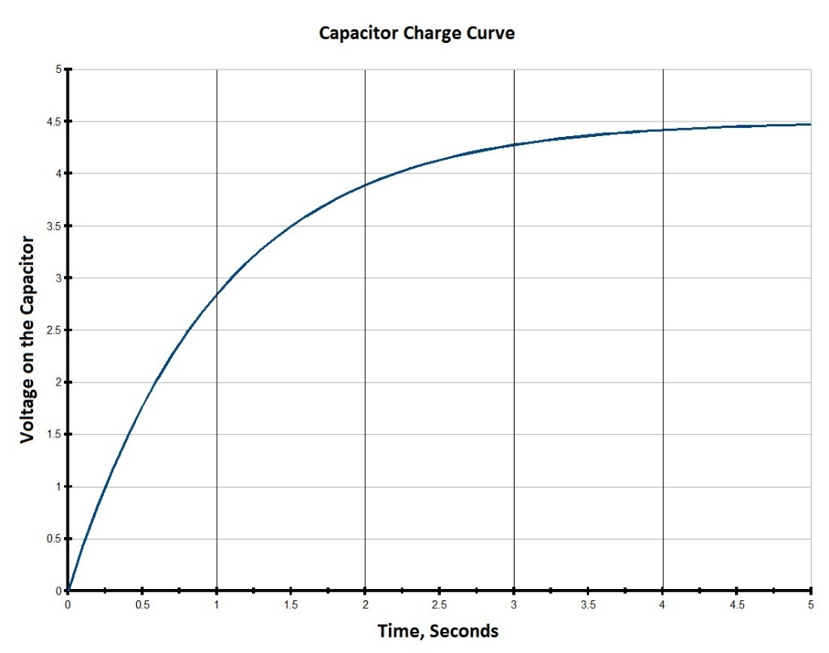

The time it takes for the capacitor to fully charge depends on the values of the resistor and the capacitor. If you keep the R constant and try two different capacitance values for C, you will observe that a capacitor with a larger capacitance requires more time to charge whereas a capacitor with a smaller capacitance requires less time to charge.

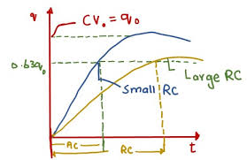

On the sensor board, the capacitor labeled as C is not a physical component but comprises two copper traces that simulate a capacitor. This phenomenon, known as Parasitic Capacitance, is a common occurrence in circuits and is typically considered negligible. However, deliberately enlarging these two copper traces allows us to leverage this effect for a specific purpose.

The capacitance of this parasitic capacitor is influenced by the size and shape of the traces, as well as the characteristics of the surrounding environment (technically referred to as the dielectric constant). When the sensor is inserted into the soil, the capacitance changes based on whether the soil is becoming wetter or drier. This alteration in capacitance subsequently affects the charging time of the capacitor.

In dry soil conditions, the capacitor has a smaller capacitance, leading to a quicker charging process. Conversely, in wet soil, the capacitor exhibits a larger capacitance, causing a slower charging time. This capacitive variation, tied to soil moisture levels, forms the basis for the sensor's ability to provide meaningful data about the soil's hydration status.

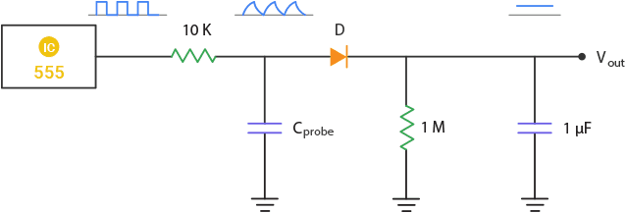

The sensor employs a 555-timer configured as an astable oscillator. The square waves generated by the 555 are directed into the RC integrator, where the capacitor is formed by the soil probe. The signal output from the integrator takes the shape of a triangular wave. This triangular wave is then passed through a rectifier and a smoothing capacitor to yield a DC output.

The resulting DC output is directly proportional to the moisture content of the soil. In dry soil conditions, the capacitor charges rapidly, leading to a larger amplitude of the triangular wave and consequently generating a higher output voltage. Conversely, when the soil is wet, the capacitor charges more slowly, resulting in a smaller amplitude of the triangular wave, thereby producing a lower output voltage. This relationship between soil moisture and the sensor's output voltage allows for a reliable and measurable indication of the soil's hydration level.

**Usage Instruction:**

When using the sensor, it's crucial to observe the following guidelines:

* **Probe Placement:** Avoid placing the probe at a depth that crosses the limit line marked on the sensor. This recommendation ensures optimal sensor performance and accurate readings.
* **Water Resistance:** The components on the sensor board are not waterproof, and therefore, they should not encounter water or splashes. To enhance water resistance, consider using a wide heat shrink tubing around the upper section of the board.
* **Edge Moisture Absorption:** Be aware that the edges of the PCB (Printed Circuit Board) may absorb moisture over time, potentially impacting the sensor's lifespan. To increase durability, it is advised to apply a protective coating, such as clear epoxy. This protective layer won't compromise the sensor's performance but will shield it from moisture-related issues.

**Wiring a capacitive soil moisture sensor to an Arduino and ESP8266**

Connecting the sensor to an Arduino is a piece of cake, you just need to three wires to perform this miracle.

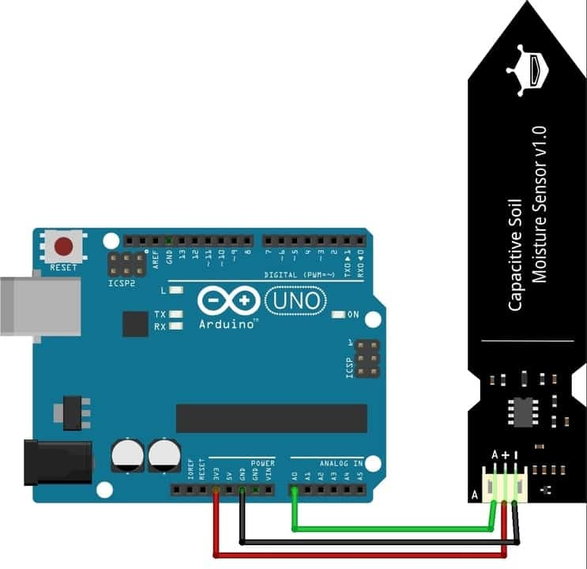

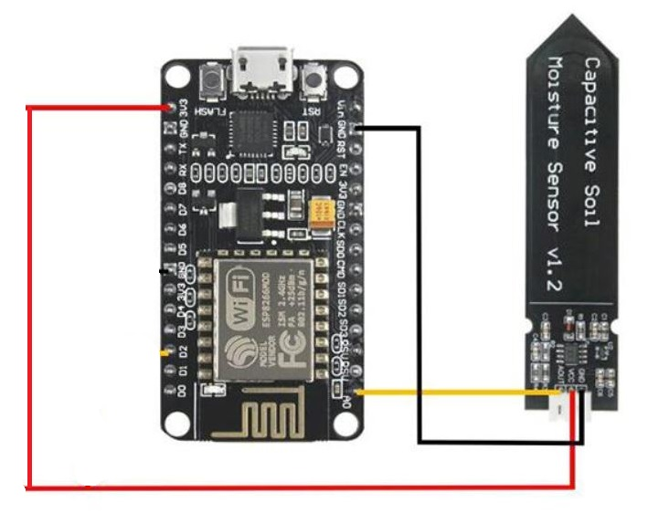

**Connections for Arduino Board:**

|  |  |
| --- | --- |
| Arduino Uno/Nano (Pin Number) | Capacitive Sensor (Pin Number) |
| 3.3v | VCC |
| GND | GND |
| A0 | AVOUT / A |

**Finding the threshold Values:**

We can basically consider ranges to know if it’s “too dry”, “too wet” and “just right”.

We need to use a simple sketch and can record the sensors output under three basic conditions:

* When the soil is dry.
* When the soil has been watered to its ideal moisture level for the plant.
* When the soil has been heavily watered.

**Code:**

// Define analog input

#define sensorPin A0

void setup() {

// Setup Serial Monitor

Serial.begin(9600);

}

void loop() {

// Read the Analog Input

int value = analogRead(sensorPin);

// Print the value to the serial monitor

Serial.print("Analog output: ");

Serial.println(value);

// Wait for 1 second before the next reading

delay(1000);

}

Upon observing the above code readings, we get similar results:

* In open air: approximately 590.
* Dry soil that needs watering: approximately 380.
* Ideal soil moisture: between 277 and 380.
* Soil that has just been watered: approximately 277.
* In cup of water: approximately 273.

**Code:**

The sketch below estimates the level of soil moisture using the following threshold values:

* < 277 is too wet.
* 277 – 380 is the target range
* > 380 is too dry.

/* Change these values based on your observations */

#define wetSoil 277 // Define max value we consider soil 'wet'

#define drySoil 380 // Define min value we consider soil 'dry'

// Define analog input

#define sensorPin A0

void setup() {

Serial.begin(9600);

}

void loop() {

// Read the Analog Input and print it

int moisture = analogRead(sensorPin);

Serial.print("Analog output: ");

Serial.println(moisture);

// Determine status of our soil

if (moisture < wetSoil) {

Serial.println("Status: Soil is too wet");

} else if (moisture >= wetSoil && moisture < drySoil) {

Serial.println("Status: Soil moisture is perfect");

} else {

Serial.println("Status: Soil is too dry - time to water!");

}

Serial.println();

// Take a reading every second

delay(1000);

}

**OUTPUT:**

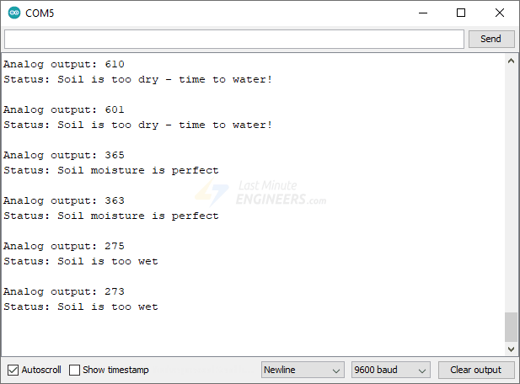



**Connection for ESP8266 Board:**

|  |  |
| --- | --- |
| ESP 8266 Board (Pin Number) | Capacitive Sensor (Pin Number) |
| 3V3 | VCC |
| GND | GND |
| A0 / ADC0 | AVOUT / A |

**Code:**

const int sensor_pin = A0; /* Connect Soil moisture analog sensor pin to A0 of NodeMCU */

void setup(){

Serial.begin(9600); /* Define baud rate for serial communication */

}

void loop() {

float moisture_percentage;

moisture_percentage =(100.00-((analogRead(sensor_pin)/1023.00)*100.00));

Serial.print("Soil Moisture(in Percentage) = ");

Serial.print(moisture_percentage);

Serial.println("%");

delay(1000);

}

**OUTPUT:**

